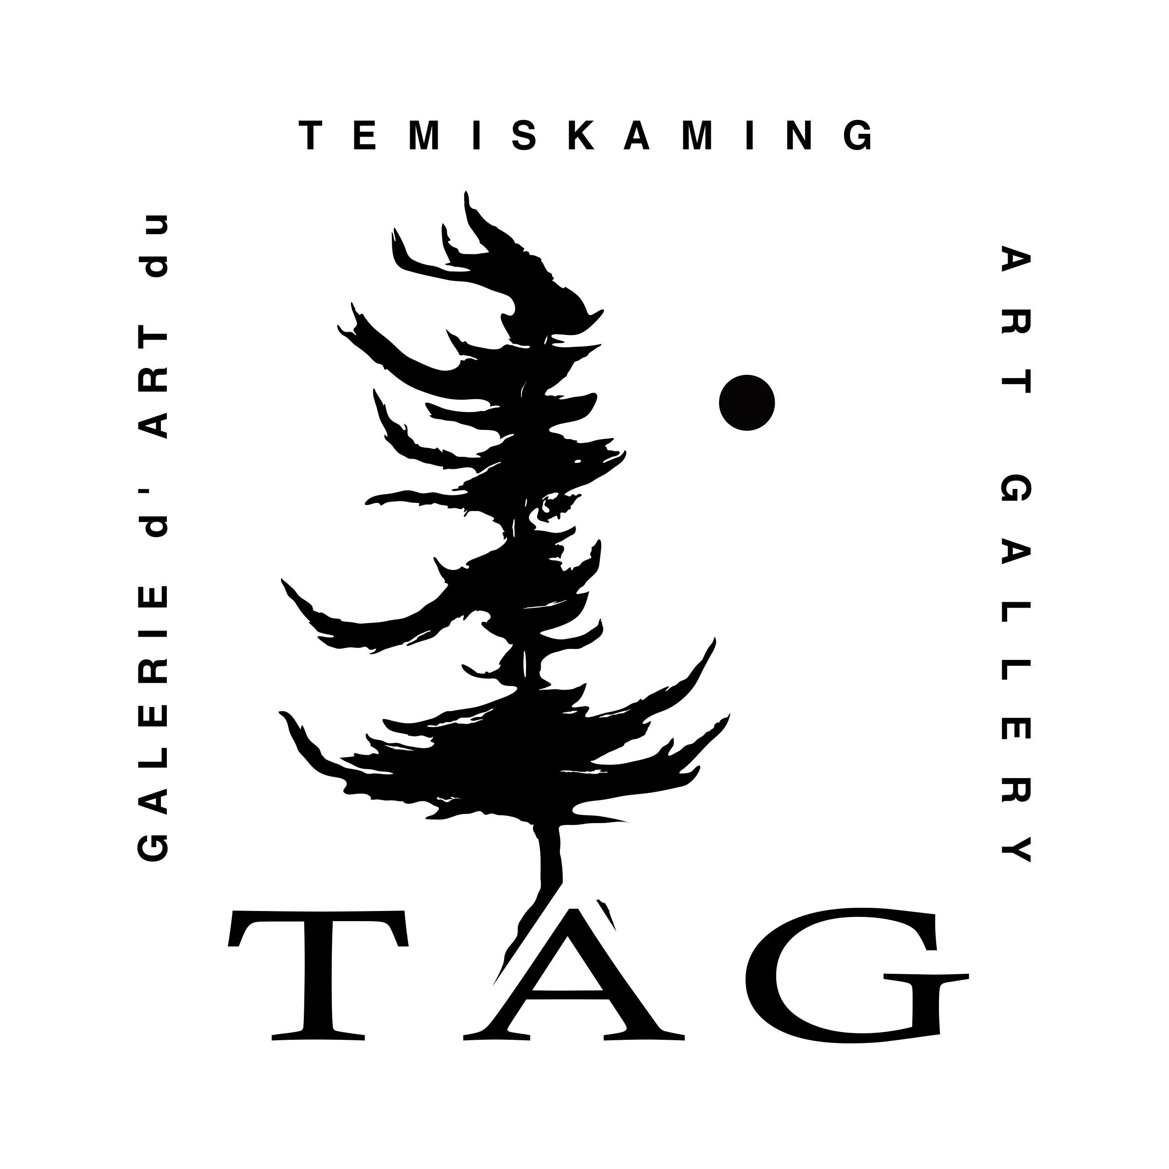
TEMISKAMING ART GALLERY
325 Farr Drive, P.O. Box 1090, Haileybury, Ontario. P0J 1K0
Telephone: (705) 672-3706 Email: temiskamingartgallery@gmail.com
Web Page: www.temiskamingartgallery.ca

Junior Artists’ Camp 2018 Registration Form
Date: Monday August 13th - Friday August 17th, 2017
Time: 9:00 Am To 12:00 Pm - 7-10 years olds
1:00 Pm To 4:00 Pm – 11 and up
Location: Temiskaming Palette And Brush Club, Haileybury

Name of Child(ren)_________________________________________
Ages(s)________________

Name of Parent/Guardian____________________________________
Address _______________________________
_______________________________
_______________________________

Telephone Number _____________________

Permission form signed and returned? Yes_____ No_____

Payment received? Yes_____ No_____

Method of payment:

Cash _________

Cheque_________ (payable to Temiskaming Art Gallery)

Credit Card (in person/called in)

Total Paid $_________________

